# App (static) assets

## Text colors

we should/could define text colors for following types/categories

* General texts
  + **GenericNavTitle:** appears on the navbar as title
  + **GenericButtonLabel:** the label appears on generic buttons (Play, Start, Clear, Finish, Next. Close etc)
  + **GenericBody:** generic text color to use as body text (e.g. loading configuration, dialog contents)
  + **GenericDialogTitle**: text appearing as dialog titles (e.g. update dialog)
  + **GenericLoadingText**: text appears for loaders (e.g. “Loading, please wait…”)
* LetterBox widget: displays characters for Question screen
  + **LetterBoxNeutral**: in case of “in progress” state
  + **LetterBoxCorrect:** in case of a correct guess
  + **LetterBoxWrong**: in case of a bad guess
* Start screen
  + **StartPageCategoryTitle:** text appearing above category icon (“e.g. Monica”)
  + **StartPageCategoryProgress**: text appearing below category icon (“e.g. 0 / 13”)
  + **StartPageError**: text displayed in case of configuration is not loaded
* Category screen
  + **CategoryPageProgress**: text appearing above question list (“e.g. 3 / 10”)
  + **CategoryPageFinished**: text appearing when category is completed
  + **CategoryPageDialogHeader:** the text of the question
* Question screen
  + **QuestionPageMainQuestion**: text appearing in the frame for “Text” type questions
  + **QuestionPageSubtitle:** text appearing below the frame for “Image” type questions
  + **QuestionPageSuccess**: text appearing in case of a good guess (above “Next” button)
  + **QuestionPageFinished:** text appearing in case of last question has been answered successfully (above “Finish” button)

**font should be provided in- ttf file**

**\* universal font family (for ALL variants)**

**\* font sizes per text type (for ALL variants)**

**\* font colors per text type AND per variant**

## 

## 

## UI images

**Generic concepts**

* UI is responsive, meaning it would appear in the very same way on every device, regardless of their resolution
* This means, that button, font sizes should be proportional the device resolution’s.
* Of course, if a device has different aspect ratios (e.g. its “narrower”) then it means we will have more space vertically - we handle this with expandable/scrollable areas
* According to the principles above, Images dimensions are specified via logical units
* We define a device’s width as 360 horizontal units called “w”
* In that sense,
  + 360w means a full-width size
  + 180w means a half-width size
  + and so on
* I’d recommend to use images for “max resolution” devices
  + the widest tablets have a resolution of 2048 x 2732
  + **in case of that device, 1w = 2048/360 = 5.6888**
  + → please prepare images with that resolution
* Please note that we usually define heights with this unit as well, so images won’t get disproportional
* SVG
  + the flutter_svg library unfortunately doesn’t support all SVG features, it is limited.
  + **Please do not use style elements NOR inline CSS, only "Presentational Attributes" can work**
  + recommendation how to export them from Adobe Illustrator: [**https://pub.dev/packages/flutter_svg#recommended-adobe-illustrator-svg-configuration**](https://pub.dev/packages/flutter_svg#recommended-adobe-illustrator-svg-configuration)

**Explanation about “Cover mode”**

Devices can have a width:height aspect ratio ranging from ~0.46 (iPhone XR) to ~0.75 (iPads)

We use a "cover mode" to display an image as "background image", this is a common mode for web&mobiles.

Relevant flutter documentation: https://api.flutter.dev/flutter/painting/BoxFit-class.html#cover

We use this mode for following images:

* title_background
* divider_background
* default_background
* dialog_background
* static_preloader
* question_background

This means that the sides & top/bottom of these pictures may be cut off, and we can only use relevant/figurative elements in the "safe center area" within the maximum resolution.

For example in case of a fullscreen picture with maximum resolution of 2048px x 2736px the safe area would be

--> width: 2736 * 0,46 = ~1258px

--> height 2048 * 0,75 = ~1536px

(so you multiple a dimension with the relevant min/max aspect ratio)

The safe area would be a rectangle with these dimensions centered in the original image.

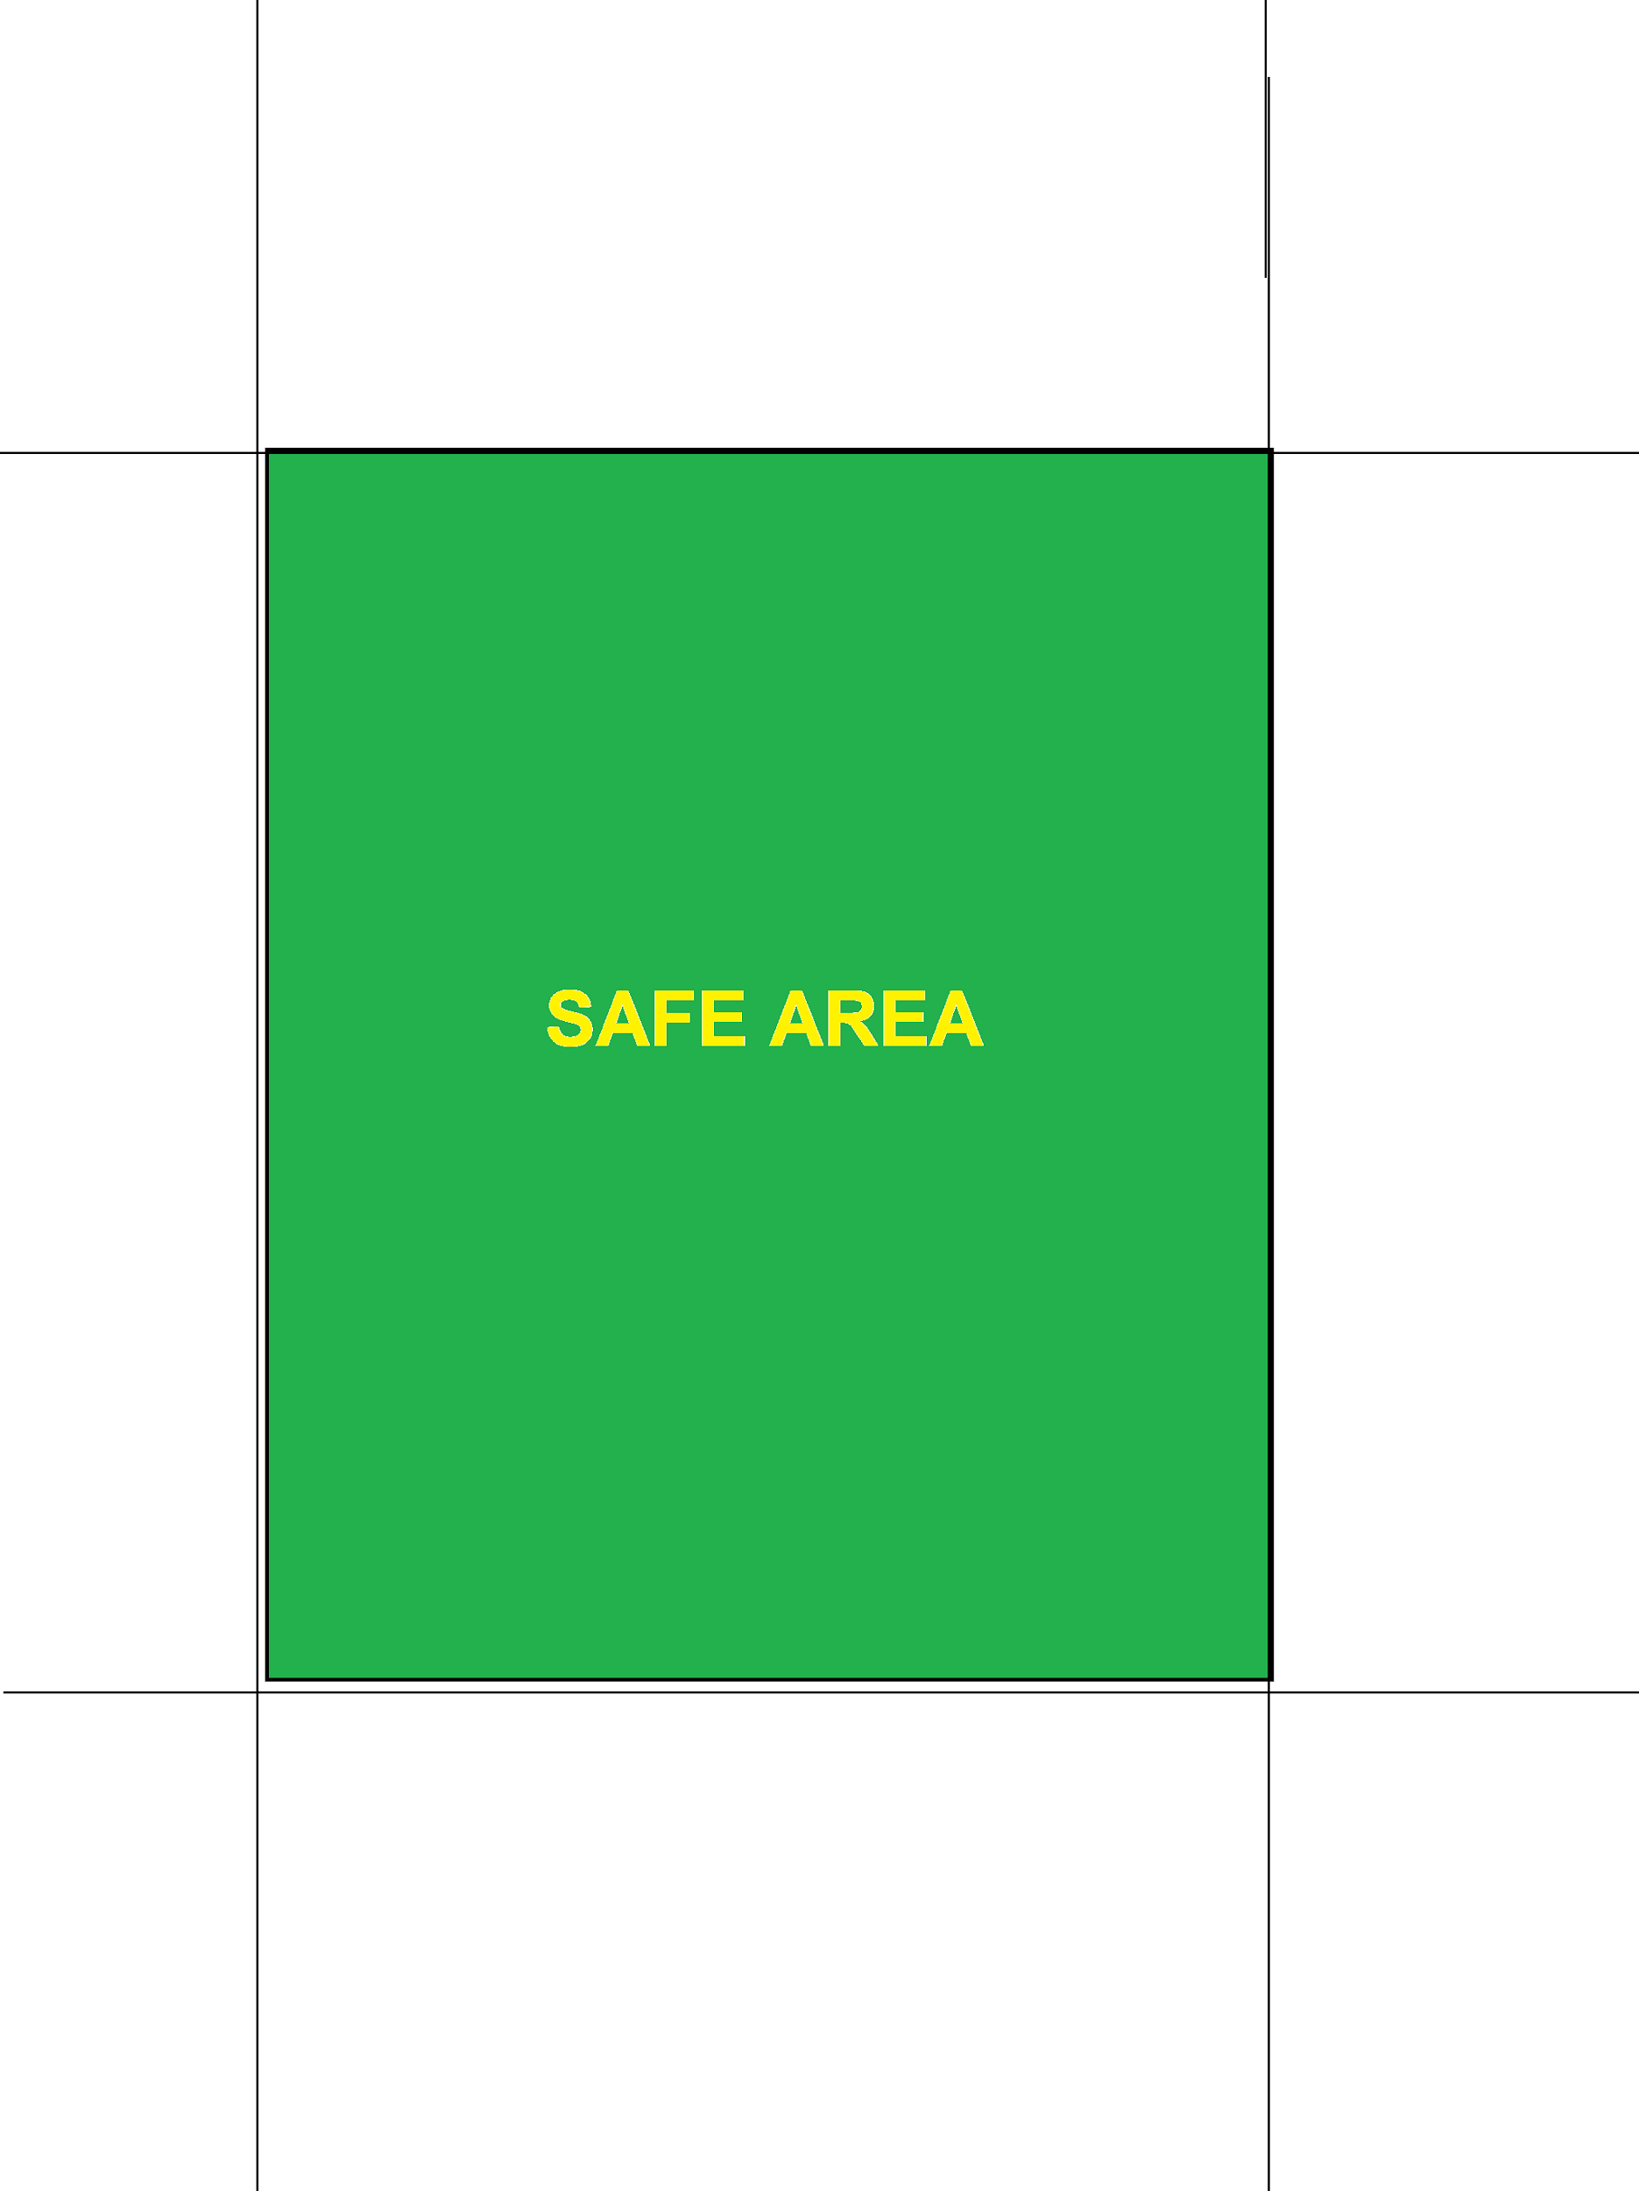

**Preloader background color**

* this is shown during preloader as progress over the initial background
* max resolution: 2048px x 2736px
* filename: preloader_background_color.png
* can be transparent? no

**Dialog border**

* serves as border for dialogs (update, question details)
* dimensions: 320w x 150w
* max resolution: 1820 x 853 px
* filename: dialog_border.svg
* can be transparent? yes, recommended (otherwise content wouldn’t be visible)



**Dialog background**

* serves as background for dialogs (update, question details)
* dimensions: 320w x 150w
* max resolution: 1820 x 853 px
* filename: dialog_background.svg
* can be transparent? no

**Title background**

* serves as a background of the navbar
* dimensions: 360w x (30px + 40w)
* max resolution: 2048 x 324px
* filename: title_background.svg

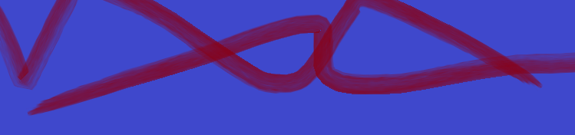

**Back button**

* it usually appears left on the navbar
* dimension: 50w x 50w
* max resolution: 284 x 284 px
* filename: back_button.svg
* can be transparent? yes



**Divider**

* a narrow, horizontal element which is between the navbar and the content area
* dimensions: 360w x 10w
* max resolution: 2048 x 57 px
* filename: divider_background.svg



**Default/Main Background**

* this serves as a generic background image for all screens
* max resolution: 2048px x 2326px
* filename: default_background.svg
* can be transparent? no
* since this should cover the whole screen, it’s resolution should be maximal: <https://screensiz.es/>
* this image will be displayed in “cover” mode, so some parts on the side/top/bottom won’t be visible!
* <https://api.flutter.dev/flutter/painting/BoxFit-class.html#constants>

**Button background**

* serves as a background for generic buttons
* dimensions: 200w x 70w
* max resolution: 1138 x 398 px
* filename: button_background.svg
* can be transparent? yes (in order to keep it rounded for example)
* text is displayed in a centered alignment, so please keep that space empty for good results



**Music off button**

* appears on Start page top right, when music is off
* dimension: 50w x 50w
* max resolution: 284 x 284 px
* filename: music_off.svg
* can be transparent? yes

**Music on button**

* appears on Start page top right, when music is on
* dimension: 50w x 50w
* max resolution: 284 x 284 px
* filename: music_on.svg
* can be transparent? yes

**Sound off button**

* appears on Start page top right, when sound is off
* dimension: 50w x 50w
* max resolution: 284 x 284 px
* filename: sound_off.svg
* can be transparent? yes

**Sound on button**

* appears on Start page top right, when sound is on
* dimension: 50w x 50w
* max resolution: 284 x 284 px
* filename: sound_on.svg
* can be transparent? yes

**Question icon unanswered background**

* serves as a background for unanswered question widgets on Category screen
* dimensions: 50w x 50w
* max resolution: 284 x 284 px
* filename: question_icon_background.svg
* can be transparent? yes, but not recommended

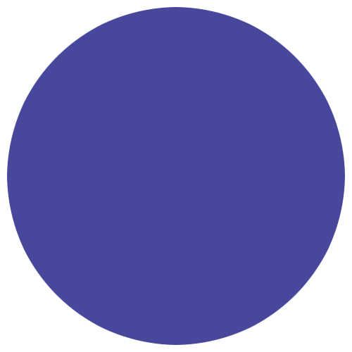

**Question icon upcoming background**

* serves as a background for upcoming question widgets on Category screen
* dimensions: 50w x 50w
* max resolution: 284 x 284 px
* filename: question_icon_upcoming_background.svg
* can be transparent? yes, but not recommended

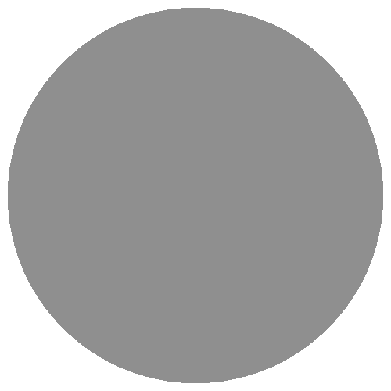

**Question icon border**

* serves as a border for question widgets on Category screen
* dimensions: 50w x 50w
* max resolution: 284 x 284 px
* filename: question_icon_border.svg
* can be transparent? yes, recommended (otherwise the background wouldn’t be visible)



**Question icon question mark**

* serves as the question icons itself on Category screen
* dimensions: 50w x 50w
* max resolution: 284 x 284 px
* filename: question_icon_questionmark.svg
* can be transparent? yes, recommended (otherwise the background wouldn’t be visible)



**Question border**

* serves as a border around question texts/images
* dimensions: 350w x 200w
* max resolution: 1991 x 1138 px
* filename: question_border.svg
* can be transparent? yes, recommended
* this should be a border, so it should be transparent in the middle, so it wouldn’t hide question itself



**Question background image**

* serves as a background image in case of IMAGE question, which is shown behind the question’s image
* dimensions: 350w x 200w
* max resolution: 1991 x 1138 px
* filename: question_background.svg
* can be transparent? yes



**Question missing image**

* serves as a fallback in case of IMAGE question, if the image is not available
* dimensions: 350w x 200w
* max resolution: 1991 x 1138 px
* filename: no_image_question.svg
* can be transparent? yes

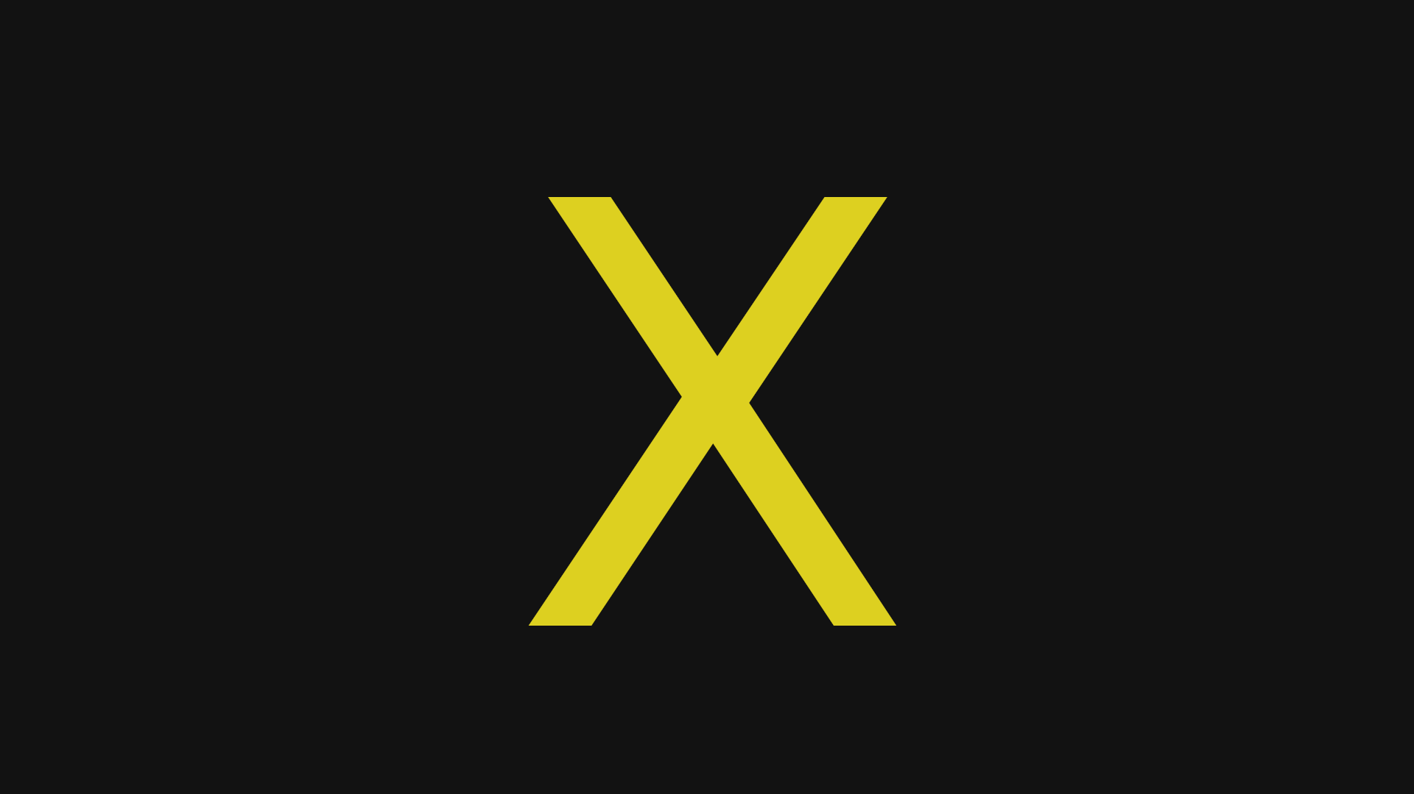

**Letterbox background**

* serves as a background image for LetterBox widgets
* dimensions: 32w x 32w
* max resolution: 182 x 182 px
* filename: letterbox_background.svg
* can be transparent? yes, but not recommended



**Letterbox border neutral**

* serves as a border image for LetterBox widgets, in case status is “neutral”
* dimensions: 32w x 32w
* max resolution: 182 x 182 px
* filename: letterbox_border_neutral.svg
* can be transparent? yes, recommended



**Letterbox border wrong**

* serves as a border image for LetterBox widgets, in case status is “wrong”
* dimensions: 32w x 32w
* max resolution: 182 x 182 px
* filename: letterbox_border_wrong.svg
* can be transparent? yes, recommended



**Letterbox border correct**

* serves as a border image for LetterBox widgets, in case status is “correct”
* dimensions: 32w x 32w
* max resolution: 182 x 182 px
* filename: letterbox_border_correct.svg
* can be transparent? yes, recommended



# JSON config images

## Category images

**Category chosen image**

* serves two purposes
  + appears on Start screen if category is selected
  + appears on Category screen for answered questions (instead of question mark)
* dimensions: 150w x 150w (square-shape)
* max resolution: 853 x 853 px
* filename: specified in the json config, as a relative path
* can be transparent? yes, recommended
* SVG

(in case of LoL, the difference between chosen/not chosen icons that the central shape is filled with color, e.g. purple here)



**Category not chosen image**

* appears on Start screen if category is NOT selected
* dimensions: 150w x 150w (square-shape)
* max resolution: 853 x 853 px
* filename: specified in the json config, as absolute path
* can be transparent? yes, recommended
* svg



**Category AnsweredQuestion icon**

* appears as icon for answered questions on Category screen
* dimensions: 50w x 50w
* max resolution: 284 x 284 px
* filename: specified in the json config, as absolute path
* can be transparent? yes
* svg

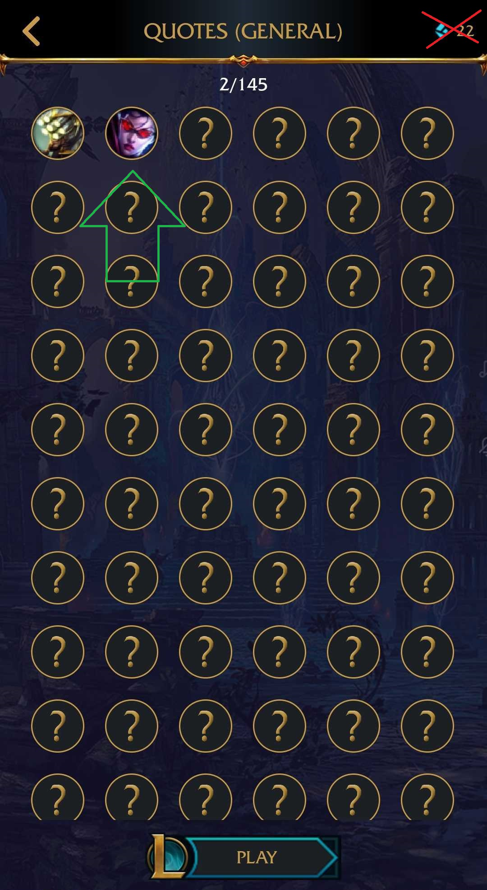

**Category background**

* this serves as a background image for all a specific category (total 5 images)
* max resolution: 2048px x 2326px
* filename: specified in the json config, as absolute path
* can be transparent? no
* png

**Image questions- not the designer task**

* these images will be displayed on the Question screen, in the “Question border”
* dimensions: 350w x 200w
* max resolution: 1991 x 1138 px
* filename: specified in the json config, as absolute path
* can be transparent? could be, but not recommended
* png

**App icon**

**android- PNG or JPEG**

**512 px by 512 px**

**Up to 1 MB**

**ios-**

**feature image -**

PNG or JPEG

1,024 px by 500 px

Up to 1 MB